Low Level Design

Project Code | Group 2
Project Name | Feedback Management System

Prepared / Modified by | Role | Date of preparation/ Modification
Sai Eshwar Myneni,  Abhishek Goyal | Designer | 18-Oct-2018
Reviewed by | Role | Date of review
Tanmaya K Acharya | Mentor
Approved by | Role | Date of Approval
Tanmaya K Acharya | Mentor
Circulation List | sai-eshwar.myneni@capgemini.com  rohit.b.agrawal@capgemini.com  abhishek.ay.kumar@capgemini.com  abhishek.b.goyal@capgemini.com  payyavula.bhavasagar@capgemini.com  snehasagari.bandarupalli@capgemini.com | Version Number : 1.0
Version number of the work product | Version 1.0

Table of Contents

1. Description Of The Unit 3
2. References 4
3. Dependencies / Assumptions 5
4. Class Diagrams 6
5. Sequence Diagrams 7
6. Design Components 8
6.1 List of UI Components…….………………………………………….…………………………………8
6.2 List of Design Classes…………………………………………………………………………………….10

7. Reusable Routines/Components……………………………………………………. 11
8. Messages 12
9. Configuration Files 13
10. Crud Matrix Table 14
11. Data Mapping Matrix 15
12. Action Flow Matrix 16
13. Stored Procedures 17
14. Program Specification / Pseudo Code 18
REVISION HISTORY OF THE WORK PRODUCT 21
Description Of The Unit

This project is aimed at developing an Airline Reservation System for booking flight tickets easily. This is a web based application that can be accessed over the web. This system can be used for booking seats in flight, searching flights and managing the booking. This is an integrated system that contains three user components, Admin component, Executive component and Passenger.

There are three categories of people who would access the system viz. Passenger, Airline Executive & Airline Administrator. Each one of them would have some exclusive privileges (for e.g. Passenger can search for existing Flights and book a seat, but the admin has the right to insert flight information and modify flight information)

- Passenger should be able to
- Book Flight
  - Manage Booking
- Reschedule Booking
- Cancel Booking
  - View Flight Status

- Airline Administrator should be able to

  - Login to the system using his/her credentials
  - Insert Flight Information
  - Retrieve Flight Information
  - Update Flight Information
  - Delete Flight
  - Logout

- Airline Executive should be able to

  - Login to the system using his/her credentials
  - View Flight Occupancy for given time period and particular airline.
  - View flight Occupancy for given city
  - Logout

References

Reference | Description
Repository reference | https://10.219.32.200/21Dec16PLPTeam1_JEE
Class Diagram | D:\Rjt\PLP\PLP Documents\ProjectDocuments\DesignDocuments\HLD\Class Diagram\AirlineReservationSystem_InsertFlightInformation_ClassDiagram.jpg
URS | D:\Rjt\PLP\PLP Documents\ProjectDocuments\Requirements\CaseStudy\Airline Reservation System.doc
UTP | D:\Rjt\PLP\PLP Documents\Testing\UTP\Test_Case_AirlineReservationSystem_InsertFLightInformation.xls
DB Design | D:\Rjt\PLP\PLP Documents\ProjectDocuments\DesignDocuments\HLD\DB Design\DB Design.xls

Dependencies / Assumptions
Dependencies:
The Airline Administrator should be logged in.
All fields in InsertFlightHome page are filled correctly.

Assumptions:
The Admin details are stored in the database.
The Flight Information will get store in the database.

Class Diagrams
Class Diagram

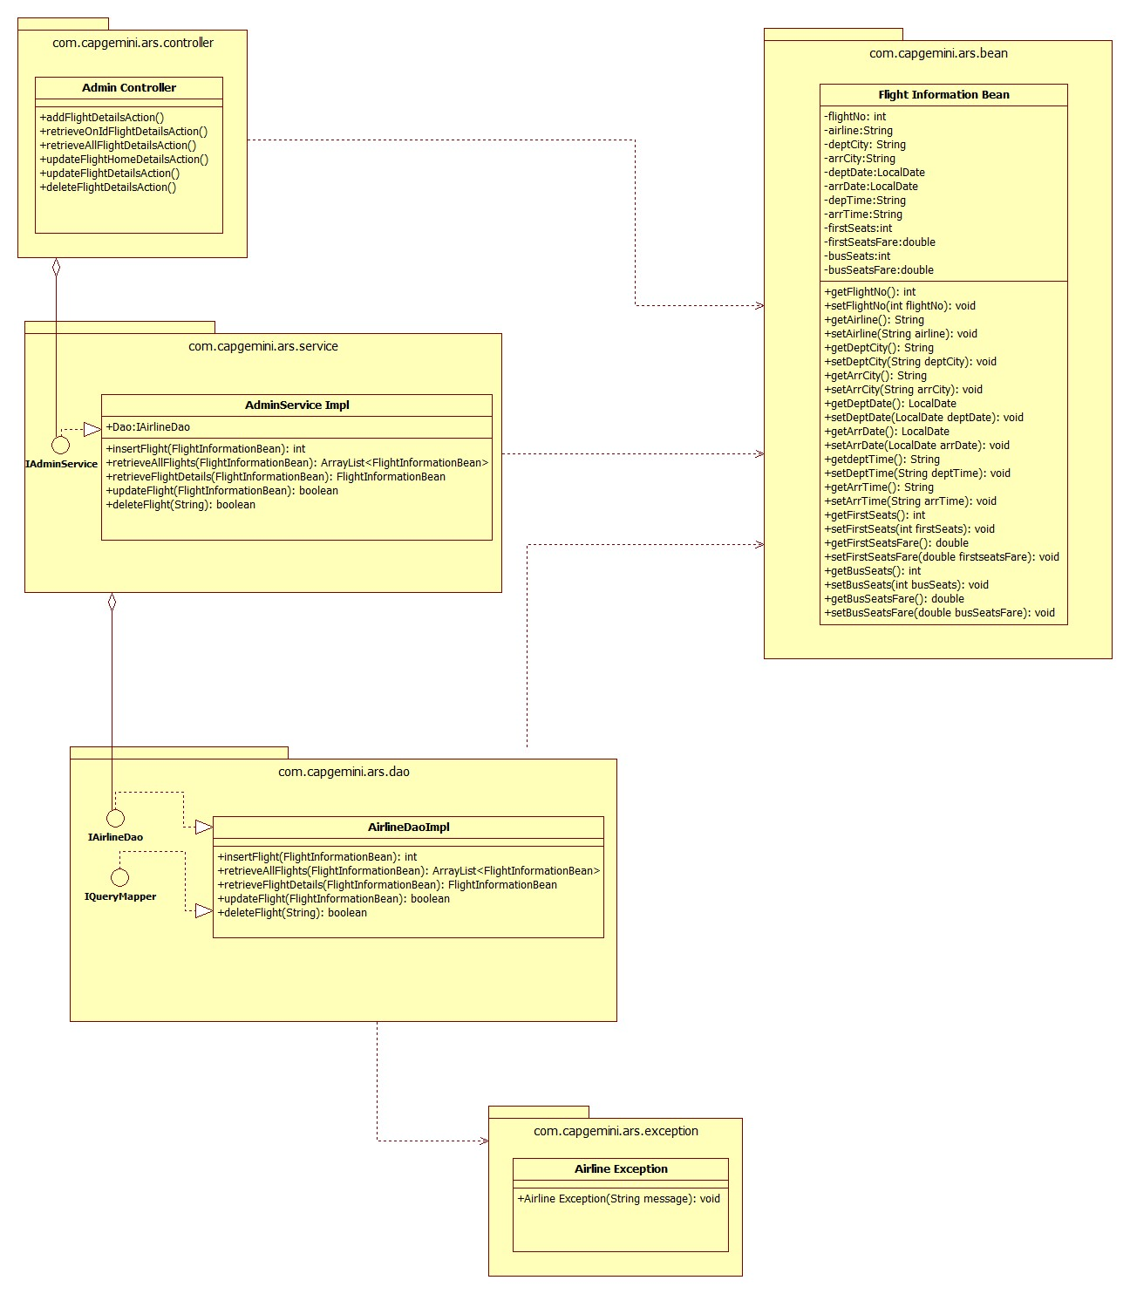

Sequence Diagrams

Sequence Diagram

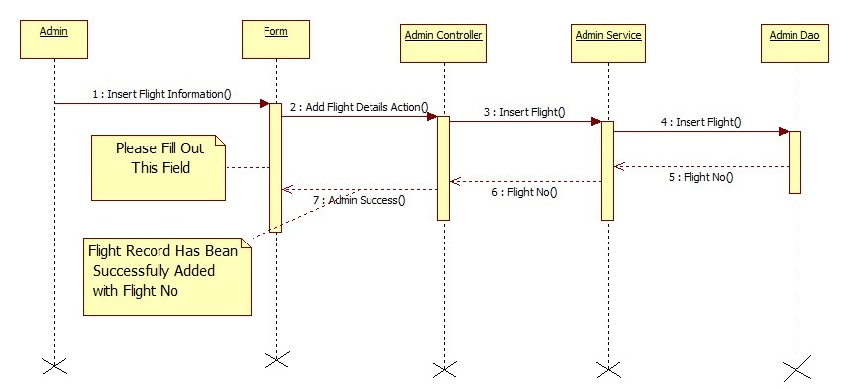

Design Components

List Of UI Components

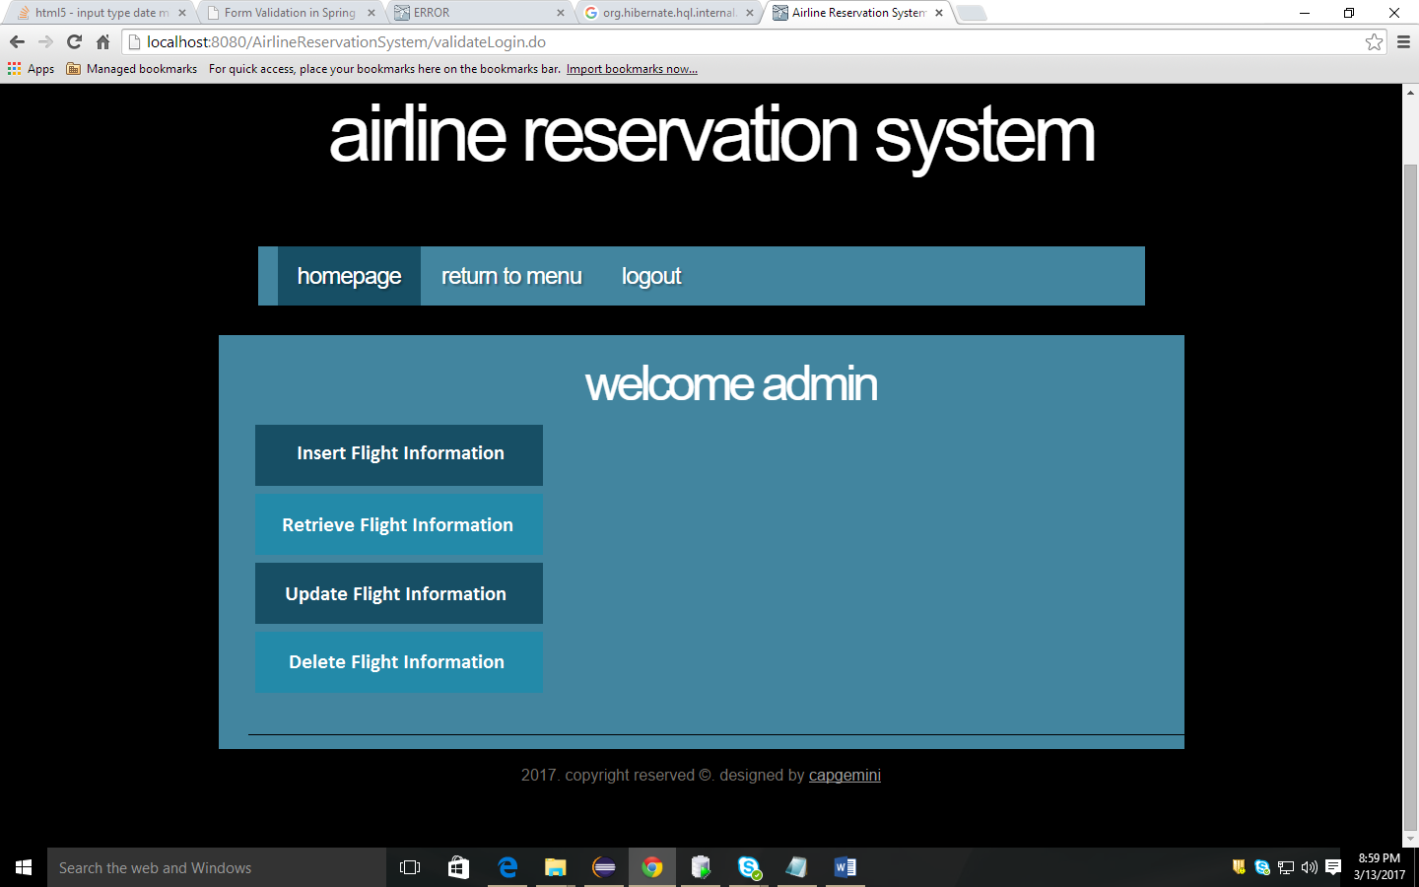

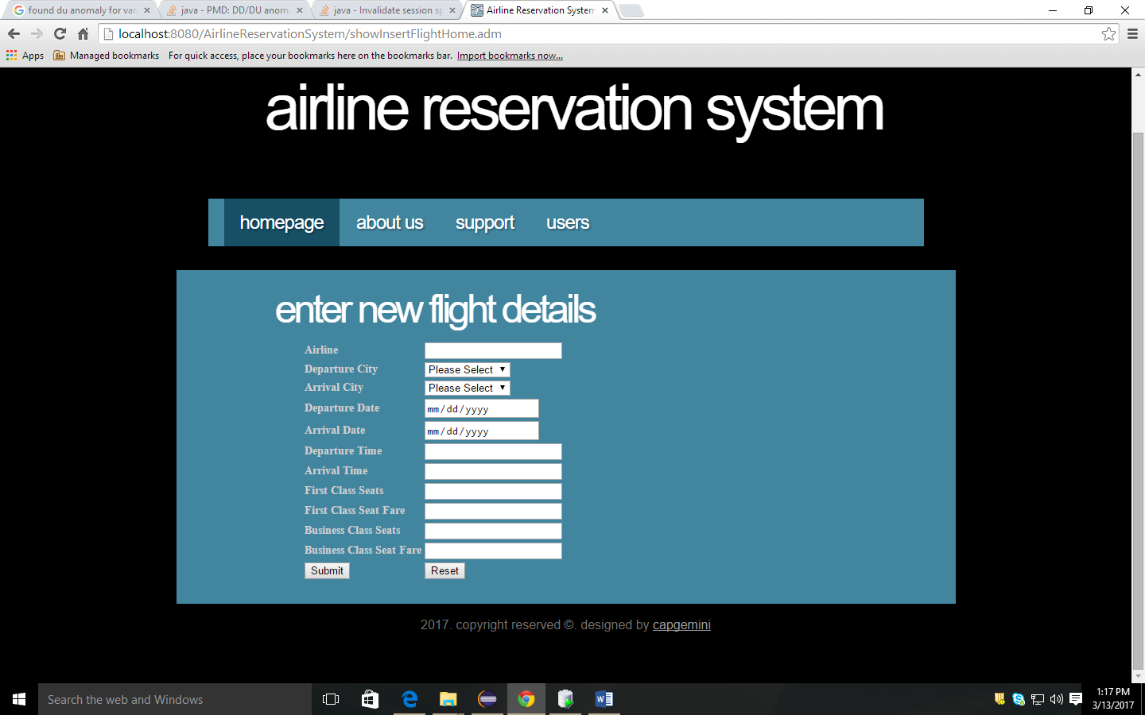

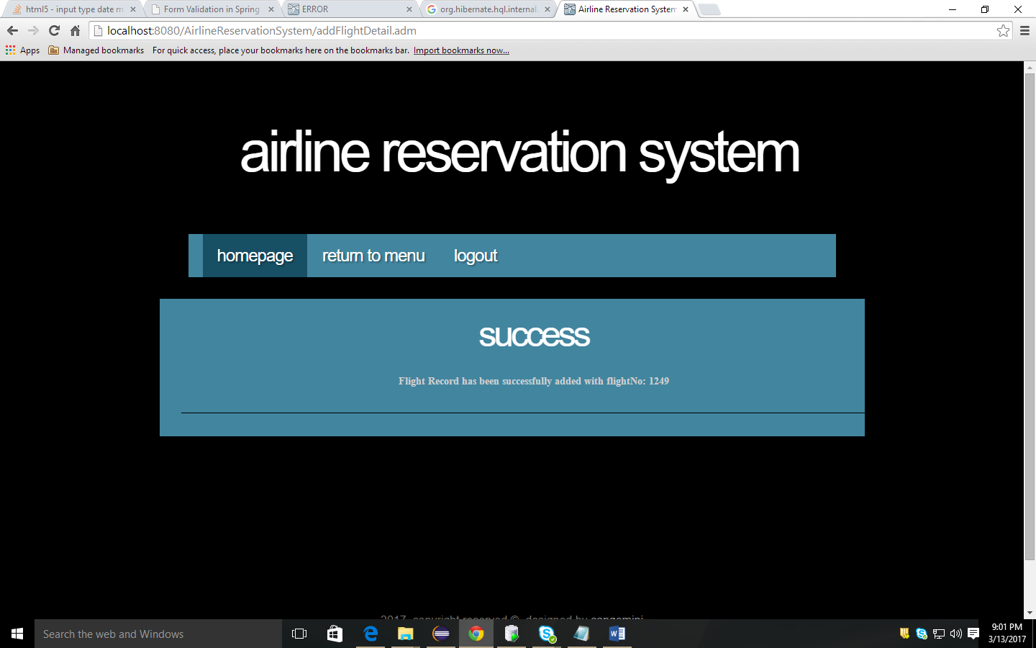
Sr. No. | LLD Name | Class Name | Method Name | Method Description
1 | Insert Flight Information`Module | FlightInformationBean | Appropriate getters and setters methods | Getters retrieve the property values and setters set the property values
2 | Insert Flight Information Module | AdminController | private void addFlightDetailsAction(HttpServletRequest request,HttpServletResponse response) throws ServletException, IOException, AirlineException | Sets the model attribute.  Calls the Service layer method to insert the Flight details in to the database
3 | Insert Flight Information Module | AdminServiceImpl | public boolean insertFlight(FlightInformationBean flightInfo)throws AirlineException | Calls the DAO layer method to insert the flight details in to the database
4 | Insert Flight Information Module | AirlineDaoImpl | public boolean insertFlight(FlightInformationBean flightInfo) throws AirlineException ) | Inserts the flight information into the database and returns the result to AdminServiceImpl

List Of Design Classes

Re-Usable Routines/Components
Re-Usable Routines/Components

- CSS files
- DataAccessException class

Messages

#. | Type | Message Text
M1 | Error | Please fill out this field
M2 | Error | Must be in characters only in range of 5 to 30!!
M3 | Error | Please select an item in the list!!
M4 | Error | Must be a valid future date!!
M5 | Error | Must be entered in format: HHMM!!
M6 | Error | Must be in 2 digits only!!
M7 | Error | Must be in digits in range of 3 to 6!!

Configuration Files

File Name | Path | Description
oracle.properties | /Development/Source | To configure database connection.
Web.xml | /Development/Source | To configure the bean properties.
Dispatcher-servlet.xml | /Development/Source | To configure the request mapping and view resolver.

Crud Matrix Table

# | Table Name | Create | Read | Update | Delete
1 | Flight Information | Y | Y | Y | Y

Data Mapping Matrix

Sr. No. | Screen Label | Field Source | Field Type | Data Type | Max Length | Data Flow | Mandatory
1 | Airline | FlightInformationBean.airline | Text Box | String | 30 | UI→D | Yes
2 | Departure City | FlightInformationBean.deptCity | Combo Box | String | NA | UI→D | Yes
3 | Arrival City | FlightInformationBean.arrCity | Combo Box | String | NA | UI→D | Yes
4 | Departure Date | FlightInformationBean.deptDate | Text Box | Local Date | NA | UI→D | Yes
5 | Arrival Date | FlightInformationBean.arrDate | Text Box | Local  Date | NA | UI→D | Yes
6 | Departure Time | FlightInformationBean.deptTime | Text Box | String | 4 | UI→D | Yes
7 | Arrival Time | FlightInformationBean.arrTime | Text Box | String | 4 | UI→D | Yes
8 | First Class Seats | FlightInformationBean.firstSeats | Text Box | int | 2 | UI→D | Yes
9 | First Class Seat Fare | FlightInformationBean.firstSeatsFare | Text Box | double | 6 | UI→D | Yes
10 | Business Class Seats | FlightInformationBean.bussSeats | Text Box | int | 2 | UI→D | Yes
11 | Business Class Seat Fare | FlightInformationBean.bussSeatsFare | Text Box | double | 6 | UI→D | Yes

Legend

UI (User Interface Only)
UI → D (User Interface to Database)

Action Flow Matrix

Sr. No. | Action | Description | Process
1 | On click Insert Flight Information in Admin Home page | Redirected to the Insert Flight Home form | The Admin clicks on the Add in the Admin Home page and gets redirected to the Insert Flight Home form.
2 | On click of Submit button in Insert Flight Home Form | The flight information is inserted into the database. | Data is entered in the fields by the Admin which gets inserted into the database when Submit button is pressed.
3 | On click Reset button in Insert Flight Home form | Redirected to Insert Flight Home page | On click reset button by the Admin in register form redirected to Insert Flight Home page

Stored Procedures

# | Stored Procedure Name  (with Description) | Input/Out Parameters | Type | Size
1. | NA

Program Specification / Pseudo Code

<ACTION: INSERT_FLIGHT_INFORMATION >

Pseudo Code:
- Client Side Scripting:
None

- Server Side Scripting:
BEGIN
Call the Service Layer for inserting the flight details into the database.
END

Pseudo Code:
14.2 <ACTION: RAISE_REQUISITION >

- Server Side Scripting:
IF Airline is Empty
Print Error Message M1
ELSE IF Airline is not in specified format
Print Error Message M2
IF Departure City is Empty
Print Error Message M1
ELSE IF Departure City is not in specified format
Print Error Message M3
IF Arrival City is Empty
Print Error Message M1
ELSE IF Arrival City is not in specified format
Print Error Message M3
IF Departure Date is Empty
Print Error Message M1
ELSE IF Departure Date is not in specified format
Print Error Message M4
IF Arrival Date is Empty
Print Error Message M1
ELSE IF Arrival Date is not in specified format
Print Error Message M4
IF Departure Time is Empty
Print Error Message M1
ELSE IF Departure Time is not in specified format
Print Error Message M5
IF Arrival Time is Empty
Print Error Message M1
ELSE IF Arrival Time is not in specified format
Print Error Message M5
IF First Seats is Empty
Print Error Message M1
ELSE IF First Seats is not in specified format
Print Error Message M6
IF First Seat Fare is Empty
Print Error Message M1
ELSE IF First Seat Fare is not in specified format
Print Error Message M7
IF Business Seats is Empty
Print Error Message M1
ELSE IF Business Seats is not in specified format
Print Error Message M6
IF Business Seat Fare is Empty
Print Error Message M1
ELSE IF Business Seat Fare is not in specified format
Print Error Message M7

- Server Side Scripting:
BEGIN
Call addFlightDetailsAction (@ModelAttribute (“insertFlight") @Valid FlightInformationBean insertFlight, BindingResult result, Model model) in Controller class in Presentation Layer
BEGIN
Call insertFlight (FlightInformationBean insertFlight) in AdminServicempl class in Service Layer
BEGIN
Call insertFlight (FlightInformationBean insertFlight) in class AirlineDaoImpl in Data Access Layer
BEGIN
Create query for inserting flight details into FlightInformation table
Return String value.
END
Return String value to Service Layer
END
Return String value to Presentation Layer

END
IF successful then navigate to AdminSuccess page and show success message.
Else navigate to Error page and show error.
END

REVISION HISTORY OF THE WORK PRODUCT
<To be maintained by projects>

# | Date | Version # | Section Changed | Details of changes made | Approved By
1
2

